***Instruction for remote access registration to electronic medical textbook collection «Thieme»***

1. Go to [http://medone-education.thieme.com](http://medone-education.thieme.com/) and click **“*Sign up for access from home”***



1. Click **“*Register now”***

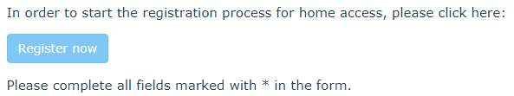

1. Fill in the first registration form and click **“*Next”***

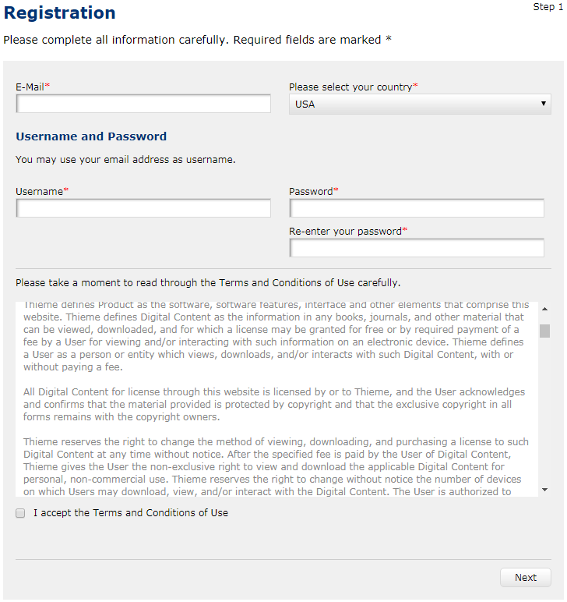

1. Fill in the second registration form:

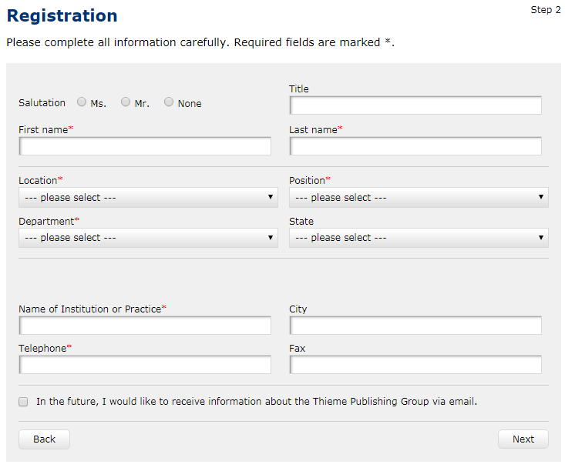

Necessary information:

* First name and last name
* Location (***University)***
* Position
* ***Name of Institution of Practice*** (Northern State Medical University or NSMU)

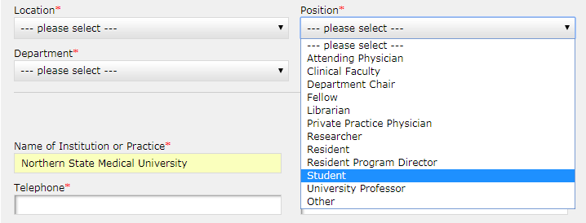

* Department:

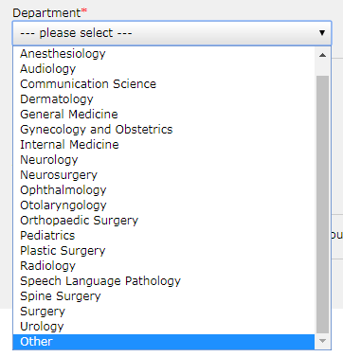

1. Click ***“Next”.*** If the registration was successful you will see the following:

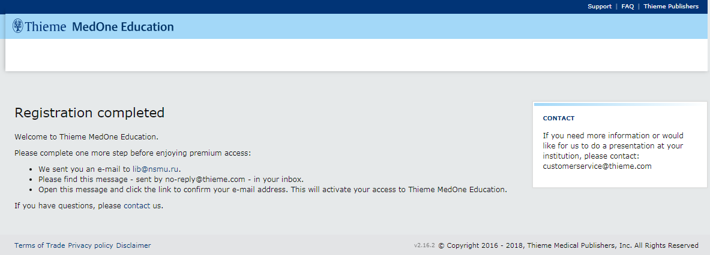

After that you will have to confirm your e-mail address to finish the registration.